Effect of Touch Math intervention On Acquisition of math skills in children with Learning Difficulties
Ms. Gopa Jhaveri,
Dr Preeti Verma,
Mrs Nishat Imam

Abstract
Math has been a stumbling block for all learners. Number sense and computation are very important early concepts of math learning programme. Students who face math difficulties impede a student’s growth and affect their performance. Primary learning sets the stage for later mathematical concepts. Lerner (1993) states, “mathematical difficulties that emerge in elementary school continue through the secondary school years. Effective teaching and appropriate instructional strategies at earlier stages can impact later learning. “People who are good at math do not become primary school teachers. As a result, the level of mathematical knowledge and skills in primary schools is generally low, and early math teaching is often poor.” (Rowe, 2007). Touch Math approach involves multisensory learning experience that is effective with all three-learner types, that is, visual auditory and tactile. Children learn faster because they access information through several learning channels. The touch points aid in association of the numerals with the real values. In the current study the research design employed was pretest, post test experimental design. The sample was selected using systematic random sampling. The sample size was 44 assigned into control and experimental group. It was observed that there was a significant difference in acquisition of math skill in children with learning difficulties using the touch math programme. Therefore it can be concluded that this approach to teaching math proved beneficial.
Keyword: Touch Math Programme, Learning difficulties
INTRODUCTION
Mathematics is a language used universally as its principles and foundations are the same everywhere in the world. It holds a common thread to many aspects of daily living and is essential that all students master the basic concepts of this subject. Mastropieri & Scruggs (2007) defines maths as an, “academic discipline concerned with the solution of problems that involve quantity or number.
Mathematics is the body of knowledge cantered on such concepts as quantity, structure, space, and change, and also the academic discipline that studies them.
Mathematics is highly relevant to every sphere of our life. Maths holds an important part of our lives it is also one of the most essentials academic subjects.
However, students who face math difficulties impede a student’s growth and affect their performance. As Lerner (1993) aptly states, “mathematic difficulties that emerge in elementary school often continue through the secondary school years.
Learning Difficulties:
Learning Difficulties is generally referred to the chronic difficulties in learning to read, write, spell, or calculate. Though their causes and nature are still not fully understood. These difficulties can be overcome by special learning strategies or with extra effort and tutoring on the part of parents and teachers.
Researchers have shown that children with math difficulties show good progress with classroom instructions, but deficit in the retrieval of basic combinations remain a deficit. (Geary, 2004). Such deficits interfere with their ability to understand mathematical discourse and to grasp more complex concepts. An inability to retrieve arithmetic facts effortlessly hampers student’s ability to perform math especially in the classroom situation where students have to perform at par with their peers within a particular time frame. It also helps to allocate mental resources required for understanding of further math concepts and procedures.
The innate ability to estimate quantities is impaired in children who have a math learning disability. The link between difficulty estimating quantities and math difficulties was seen only in children who had a math learning disability, and not in those who did poorly in math but were not considered to be learning disabled. Learning disabilities are usually not diagnosed until students have been in school for about two years, but there are often early signs of disabilities that parents may notice. Math deficits coexist with reading deficits and are usually reported as deficits either by themselves or along with other reading difficulties (Garnett ,1998).
Characteristics Of The Students With Math Difficulties
Vinson (2004) characterized students with mathematics anxiety as exhibiting:
- Uneasiness when asked to perform mathematical computations
- Avoidance of math classes until the last possible moment
- Feelings of physical illness, faintness, dread, or panic,
- Inability to perform on a test and
- Utilization of tutoring sessions that result in very little success
Mathematics anxiety interferes with the manipulation of numbers and the solving of mathematical problems in a wide variety of ordinary life and academic situations. Math anxiety can cause one to forget and lose one’s self-confidence. It has been found that imposed authority, public exposure and time deadlines that is a regular part of the traditional mathematics classroom is the cause of great anxiety in many students. They may also have a particularly difficult time storing and easily retrieving information in their memories (Gersten et al., 2009)
Students that struggle in these areas suffer from low self-esteem and the end result impacts jobs and everyday lives. (May 2008). Students experience difficulties in ‘spatial relationships’, ‘sense of body image’, ‘visual motor and visual perception abilities’, ‘concepts of time and direction’ and ‘memory’ (Lerner, 1993). A solution for math disabilities requires different methods, emphasis, and variation of teaching presentation (Garnett, 1998).
In mathematics, difficulties arise in acquiring concepts of quantities, seeing relationships between numbers, reading and writing number symbols (Strauses and Lehtinen, 1947). A disturbed spatial perceptions leads to the inability to perceive to relative distance between numbers on a number line, e.g. is 3 close to 4 or 6? Such difficulties interfere with visualization of the entire number system. Students cannot write numbers easily, cannot read and align numbers properly, thus make errors in computation.
Learning problems may be due to failure on part of the teacher to teach them properly or to give adequate drill of the skill (Wallace and Kauffman, 1978).
Researches suggest that approximately 5%-8% of school age children struggle with mathematics, with poor conceptual understanding, immature counting and arithmetic strategies, and/ or retrieving basic math facts (Geary, 2004). Students may also show difficulties in the acquisition and mastery of pre-math skills such as pre-math concepts, (e.g. big/small, near /far etc.) one-to-one correspondence at the pre-primary level and computational skills (i.e. addition, subtraction etc.) and problem solving skills at higher level. These students also show difficulties in cognitive processes, memory (working memory, short term memory, long term memory), perception (visual, auditory), spatial relations, and logical reasoning (deduction, induction, analogies). Moreover, difficulties in acquisition of concepts and skills at the early school years have a bearing on the acquisition and further learning of mathematics.
Geary (2004) suggest that mathematical difficulties, especially during the early years, may lead to frustration, avoidance and anxiety which may make math learning much more difficult and may create a vicious circle that is very difficult to alter later on .To prevent this the children should be taught effective and easy to learn method or strategy.
Wood (1980) states 5 reasons why the children with learning disability experiences difficulties in learning modern mathematics: - 1) The multiple associations of words confuse the child.2) The lack of mastery of number facts prevent solving problems based on these facts.3) The symbol notation is also confusing.4) Teachers are inadequately prepared to teach fundamentals.5) Parents have been virtually eliminated as adjuncts to the teaching process.
Perceptual, memory and attention deficits effects training on the acquisition of conservation in learning disabled. (Fincham and Meltzer, 1976). Many of these students have had experiences of failure and frustration with mathematics by the time they receive intervention.
Strategy Training In Math
Most students find strategies effective and try to utilize these strategies to solve mathematical problems. Students with learning disabilities, whether the disability occurs in math or in another area that affects math performance, need explicit instruction in strategies that work. Research shows that without direct intervention dyscalculia persists. Almost one-half of children who were identified with dyscalculia in the fourth grade are still classified as having dyscalculia three years later (Lerner, 1993).
Mathematics is developmental in nature and should be taught through sequential cases. Although the sequences are previously determined, the students’ development is individualistic. Adaptations in accordance with the students’ needs are required in education so as to ensure effective teaching. These adaptations include course planning, differentiation of teaching methods, arrangement of content and arrangement of evaluation.
In general education classrooms, adaptations and arrangements are required in teaching mathematics not only for the students with special needs but for those students having difficulties in learning difficulties. Minor changes made by mathematics teachers in the presentation of mathematical concepts would not only increase the number of correct answers given by the students, but also help them to understand the process more clearly (Lock, 1996).
There are several strategies that have been developed in Mathematics to help students with learning disabilities. There are two ways to teach math: the traditional method and the reform method. Neither method is better; each has its merits. Students learn best, though, when a mix of both traditional and reform methods are employed within the classroom. Some children understand the abstract nature of numbers, while others need to see it in front of them for it to have meaning.
Traditional math relies upon rote instruction. Children are drilled on math facts. They use flash cards and take timed math tests. Some amount of traditional math is necessary to ensure that a child has a good foundation in number sense, for without it, a child cannot begin to understand how numbers are integral to life. Reform math is a much newer approach to learning. It involves students collaborating to problem solve.
Low achieving students need specific instruction in situation and application. Students with math difficulty, require engagement in learning with application, plenty of feedback, and teaching that correlates with personal learning styles (May, 2008). Touch Math is one such instructional strategy that enhances a student’s Maths computational skill by using all the techniques in reform math. Touch math provides relevant strategies to these students with engagement, feedback, and multi sensory methods (Scott, 1993).
Touch Math
In the Indian context, the quality of teaching in schools needs to improve & new strategies need to be introduced to cater to large number of students with varied abilities in one class. Indian math teachers tend to focus on information covered in the tests, stressing fact memorization and number tables, rather than addressing individual needs. Students who have trouble with mathematics are extremely disadvantaged not every teacher in class uses effective instructional methods nor special efforts are made to develop interest in maths. Students fear maths and find themselves unfit to handle life situations involving maths. Touch Math builds the crucial understanding of math that translates into success.

Touch Math method of touching and counting on numerals to generate number facts is effective with all three major learning types: tactile, as well as auditory and visual. The number facts are often referred to as the "basic" facts, and the students are never shaky on the number facts, if using touch maths. If students remember a fact, they write it down, if they don't remember it, they figure it out. Touch Math is a dictionary for the number facts.
Touch Math uses a multisensory approach designed for auditory, visual and tactile/kinesthetic learners. Students see, say, hear and touch using Touch Points on numerals. They learn faster because they access information through several learning channels. As they see, say, hear and touch using the signature Touch Points, they begin to associate numerals with real values. They learn that a numeral (3, for instance) is not just a symbol on a page, it represents a quantity such as three pens, three lions, three oranges or three Touch Points.
The sequential strategy of Touch Math gives students the support they need to be successful every step of the way. Once students understand the Touching/Counting patterns, they can answer simple math problems easily and correctly. Soon, they build self-confidence and progress to more advanced concepts.
Touch Math is the use of a consistent, structured pattern of Touch Points on the numerals. The use of specific patterns to represent numbers in Touch points when compared to using a variety of patterns with diverse objects for representing numbers, was found to be effective as it facilitated children using strategies for computation other than their fingers, as well as sped up their answers. Use of structured representations of numbers helps children develop more sophisticated strategies, such as non-finger computation strategies. Structured materials seem to be a better tool than using a variety of materials. Researchers have shown that children’s mental images are more consistent when they internalize one structured representation of the numbers, as opposed to using a variety of interpretations.
Mental development follows three stages: concrete, pictorial, and symbolic. At the beginning of instruction and in early years, children learn through manipulative activities, they move to the use of pictures, and then, finally, they can rely on symbols to represent the pictures and objects (Bruner,1963, 1966).
In Touch Math, children can use manipulative to solve the computation problems. They also relate the manipulative (or counter) to the Touch points on each numeral. The very act of touching and counting the Touch points provides a concrete experience. In fact, each numeral (3 as an example) is at the highest level of representing knowledge, since it is a symbol. Touch Math bridges the gap between the pictorial and symbolic levels by putting Touch points on the numerals to show the number (or quantity). The numeral serves as the symbolic and the Touch points serve as the pictorial, providing a picture of the quantity on the symbol.
Objectives of the study:
1. To study the effectiveness of Touch Math program on Acquisition of mathematical skills in children with Learning Difficulties.
2. To compare the Touch Math program with Traditional Teaching Method for Acquisition of mathematical skills in children with Learning Difficulties
Research question:
- Will Touch Math be more effective on acquisition of mathematical skills in children with Learning Difficulties?
Research Design
The pre-test post-test equivalent groups design was adopted for this study. Equal number of subjects group from std II, were randomly assigned to control and experimental groups, in order to eliminate all the threat to internal validity except mortality. Thus, any difference between experimental group and control group are due to the treatment.
The pre-test post-test design was employed to study the effectiveness of the Touch Math Programme on acquisition of math skill in children with Learning Difficulties.
Sample
In order to get a fair representation of the population the researcher took into account all the variances within the population in the sample selection process. Thus, making the sample a representative of the population at large, in order to establish external validity and reliability.
Sample Selection Procedure
The geographical area selected for research was from Churchgate to Santacruz in Mumbai. The researcher approached 30 schools within the geographical areas. The researcher restricted the schools to the I.C.S.E and the SSC educational boards. The sample consisted of subjects studying in the 2nd class between the age group seven to eight years. Both boys and girls were included in this study. Out of the 30 schools to which permission was sought only four schools agreed to participate in the research. Once the schools agreed to participate, the random sampling method was used to select the participants.
The selection of the participants was based on the marks obtained by all the 239 subjects in their previous mathematics examination. The mean and Standard Deviation (SD) of these scores was calculated. Only those subjects who scored 1 SD below the mean in the previous math exam were selected for the study. Out of 239 using the systematic random sampling method 44 subjects were assigned into Control and Experimental group. Thus the final sample consisted of 44 subjects. There were 22 subjects in the Control group and 22 subjects in the Experimental group.

Development of the Test
The stages of test development were strictly adhered to
- Selection of items:
Prior to selection of test items, an in-depth study of the areas of mathematical abilities and the curriculum followed in schools was done. Textbooks of different examination boards were carefully studied for selection of appropriate items for the test. The preliminary form consisted of 25 items. The selected items were then compiled and given to experts in the field for content validation. The suggestions of the experts were incorporated into the tool.
- Pilot testing
- Final Form of the Pre-test and post-test:
The final draft consisting of 20 items was prepared. The final form of the test covered 2 operations of mathematical ability, namely Addition and Subtraction.
Procedure for Data Collection.
Before starting the study, the researcher attained permission from the respective schools. The data was collected in three phases.
Phase I Pre- Test
The pre-test was administered on the total of 44subjects from 4 schools, in a group of four subjects at one time. Instructions given to the subjects were in English and it was ensured that the subjects clearly understood and followed the instructions. The subjects were allowed sufficient time to complete the test. No time limit was set for completion of the test. On an average the subjects took half an hour to complete pre- test.
Phase II Treatment
44 subjects were randomly divided into two groups, namely the experimental and control Group. Each group constituted of 22 students each. Subjects in the experimental Group were exposed to the Touch Math Program by the researcher whereas their respective math teachers .The researcher taught the subjects in groups of four exposed the subjects in the Control Group to the Traditional Method. Experimental group and the control were taught addition as well as subtraction computation skills simultaneously in the resource room and their class-room respectively. The content taught was up to 3-digits addition and subtraction with and without carry-over & borrowing respectively.
The Experimental Group learnt addition and subtraction using the Touch Math programme. The experimental was given following instructions: “Today I am going to teach you a new method to do additions. This method is called Touch Math. First we will learn to use it on numbers 1 to 9. The colour dots on each number tell us the “Touch points” and you can count the Touch Points by using your finger or a pencil.

 | “Like this is number one, number one has one touch point now touch and count the number of points on this number :one”
 | “This is number two there are two touch points here. First count the top point and then the bottom
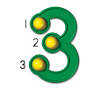 | “The number of touch points in the number 3 is three. Now touch the three points, on at the beginning, the other in the middle and the third at the end of the number, now counts using these three touch points. One, two, and three."
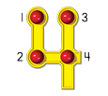There are four touch points in number 4, two are on the left side and two are on the right side. We begin counting them from left side top point and then count the right side top point, now we count the bottom points; count the left side bottom first then the right side bottom point. One, two, three, and four."

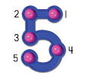 | “As you all can see there are five touch points in number 5.We begin counting the five points one is at the right side top ,second is on left corner ,third is at the beginning of the stomach of five, fourth is the belly button and fifth one at the end of the stomach. Now count using these five touch points. : One, two, three, four, and five."  “We have to remember that after number five all the numbers will have two Touch Points as the points are increasing in number."
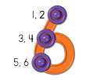 | “As you all can see we begin the use of double Touch Points (dots with circles) with number six. We will count these double Touch Points twice whenever they appear. Let’s start counting the top point first One-two then the middle one three-four, and the last one at the bottom five-six."
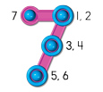 | “Number 7 has seven touch points. First we count the top double touch point on the right side One-two, and then the middle one three-four and then the bottom one five-six, in the end we count the single point by saying punch the nose "seven."
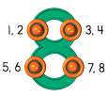 | "Number has 8 touch points, four are on the left side and four are on the right side .So we begin counting them from left side ,first we count the top point One-two and then the top right point three-four, now the left side bottom point five-six and then the right side bottom point seven-eight."
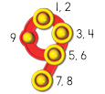 | “Number nine has 9 touch points. Like number 7 we will begin counting with double touch points. First we begin with the double touch point on the top One-two, then the second touch point three-four, then the next touch point five-six, then the last touch point at the bottom seven-eight, then will count single point by saying punch the nose : "nine."
 | “Does the zero have any Touch Points? No, so we do not touch and count zero."
Now we know that numerals 1 to 5 have single Touch Points and numerals 6 to 9 have double Touch Points.
The subjects counted numbers 1 to 5 aloud as they touched the single touch Points. For numbers up to 5 the subjects had to touch at the points only once where as for numbers 6 to 9 each point had to be touched while counting the points for each number. To ensure that subjects arrive at the right twice; subjects had to follow a pattern answer, that the subjects were constantly reminded to follow the sequence of pattern for each number. The researcher each group and immediate feedback was given to the subjects. The subjects practiced touching the Points of the numbers in the correct sequence till they attained mastery in counting each number.
After the subjects attained mastery in counting the touch Points, the subjects learnt addition .The content included one digit to one digit with and without carry-over, two digits with two digits with and without carry-over, and three digits to three digits with and without carry-over. Addition in Touch Math was taught in 3 phases:
Phase I – Beginning Addition
Phase II – Continous Addition
Phase III –Addition with carry over

Phase I – Beginning Addition with single touch point
+

+
14

Beginning Addition with double touch points

“Remember all the numbers after five, each touch points has to be touched twice”. The subjects were asked to read the sum 8+6. “Now read the problem by touching the numbers and sign. Eight plus six, which is the bigger number- yes eight is a the bigger numeral , now begin counting the touch points on the top numeral eight. There are four touch points in number 8 each touch point will be counted twice to make it 8, so let’s count them starting from the left side top point one- two, three- four, five-six, seven-eight. Now continue counting the points on number 6. Six has 3 touch points but remember each touch will be counted twice, so begin from the top touch point nine-ten, eleven-twelve, and thirteen-fourteen. The last number you said is the answer, which is fourteen. Now read the problem sum and the answer again, eight plus six is fourteen.
Phase II – Continuous Addition
7
+
10

When subjects successfully mastered Beginning Addition task, the touch points from the largest number were removed. For learning Continuous Addition the subjects were taught the following steps. The subjects were asked to read the sum. “First we will read the problem by touching the numbers and the sign, seven plus three. Here you will see that the points are removed from the larger number, seven so we just have to touch and say the name of the larger number, seven. Now continue counting the points on the smaller number 3.Three has three touch points so eight, nine, ten .The last number you say is the answer, which is ten. Write the answer and say the problem with the answer aloud again, seven plus three is ten”
 | 6 | 5
+ | 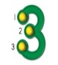 | 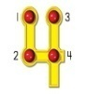
 | 9 | 9

Two digit Addition without carry over was done similarly.

Phase III- Addition with carry over

 | 1
 | 4 | 6
+
 | 8 | 0

Table.3.4.2.v Two digits Addition with carry over
 | 1 | 1
 | 6 | 8
+ |  |  | 6
 | 8 | 1 | 0
Another visual clue that is added to the process of addition with carryover is the box and an arrow, as shown in Table 3.4.2.iv. “We will learn to add two digit addition sums with carry over. First start from the right side where the arrow is indicating. Touch both the numbers on the right side column (ones’/units’ column) and the sign and say the problem, six plus four. Now Touch the largest number in the units column and say its name, six. Now continue counting the points on the smaller number four, seven, eight, nine, and ten. Put 1 in the box above the Tens’ column and write 0 below the number four in the ones’ column. Then repeat the problem in the unit’s column, six plus four is ten. Put one touch point on number ‘one’ in Ten’ s column and say the problem for the ten’s column, one plus ,four plus, three. Then point the largest number and say its name ‘four’ and continue counting the points of the carry-over number ‘one’ and then the other number in the Ten’s column ‘three’, which is Five, six, seven, eight. The last number you said is answer, eight. Write the answer and repeat the problem, four plus one plus three is eight. Finally repeat the whole problem with the answer, forty-six plus thirty-four is eighty”.

Fig.3.4.2.vi Three digit addition with carry over
After adequate practice was given for two-digit sums with carry-over; Three-digit addition with carry-over sums were given to the subjects. The instructions for three-digit addition are the same as the two-digit addition till the tens column. The additional instructions were given when the subjects had to carry over to the hundreds’ column and add all the numbers in that column.
Through the session the subjects were given the initial worksheets of two digit and three digit numbers with Touch Points only on the smaller numbers and then without any touch points. When the subjects were given worksheet without any Touch Points, they were encouraged to make appropriate Touch Points on the numbers in the sums given; till they could manage without the Touch Points.
After the subjects achieved 80 % accuracy in mastering Addition, the researcher taught Subtraction which included one digit to one digit with and without borrowing, two digits with two digits with and without borrowing, three digits to three digits with and without borrowing.
Subtraction
1 1 2 0 1 2 3 4 5 6 7 8 9 10 11
11 11 12 13 14 15 16 17 18 19 20

Backward counting
Backward counting is a pre-requisite for doing subtraction. Therefore, before introducing problem solving in subtraction the students practiced counting backward orally from 20. They learnt to count backward from 17 to 5, 20 to 15, 14 to 3, 16 to 9 etc. Backward counting is necessary as Touch Math Programme requires it to carry out subtraction. The instructions for backward counting were given as follows:
“Look at the number line given to you and lets start counting backwards together from 20 to 0. I will ask you to count backward from a particular number till another number e.g. if I say count between 17 to 10, you have to count backwards and say, seventeen, sixteen, fifteen, fourteen, thirteen, twelve, eleven & ten”
Backward counting was reinforced in various ways, like physically walking backwards on the floor tiles, playing backward counting game in a group.
Subtraction in Touch Math was taught in 3 phases:
Phase I – Beginning Subtraction
Phase II – Subtraction without borrowing
Phase III –Subtraction with borrowing

Phase I – Beginning Subtraction

5
2

Single digit subtraction
The researcher informed the subjects, in the subtraction sums, the Touch Points are given only in the bottom numbers. The subjects were first taught simple subtraction sums using the touch points. The subjects were asked to read the sum 5-3. “Now read the problem by touching the numbers and the sign, five minus three. Now touch the top number and say its name, five. Then touch the bottom number, three, and count backwards by touching its Points, Four, Three, Two. The last number said is the final answer, which is ‘two’. Write the answer and repeat the whole problem, five minus three is two.”
• Subtraction without Borrowing

 | 4 | 6
__
 | 1 | 2

An arrow serves as a visual clue, as it did in addition, to show subjects which side to begin subtraction. For the two-digit subtraction without borrowing, the process is the same as the one digit subtraction. “First start from the right side where the arrow is indicating. Touch both the numbers on the right side column (ones’/units’ column) and the sign and say the problem, six minus four. Then touch the first number, say its name, six, and count backward using the Touch Points of the lower number, five, four; three, two. The last number you said is the answer so write two as an answer in one’s column. Now in the ten’s column touch both the numbers on the left side column and the sign and say the problem, four minus three. Now touch the top number and say its name- four, then touch all the points on the lower number three and count backwards, three, two, and one. The last number said is the answer, that is ‘one’ Write the answer, and then repeat the sum again: four minus three is one. Now repeat the whole sum and the answer aloud: forty six minus thirty four is twelve.” Always ask the touch points of each number

Subtraction with Borrowing

 | 4
 | 5 | 1 2
___ |  | 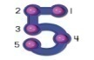
 | 1 | 7

Table.3.4.2.x Subtraction with Borrowing
Before starting sums with borrowing, the subjects were taught borrowing statement “I must borrow, if I cannot continue to count with single touch point
backward using all the Touch points.” Or can say “Bigger bottom Better Borrow”.
“Let’s start from the right side where the arrow is indicating. Touch both the numbers on the right side column (ones’/units’ column) and the sign and say the problem, two minus five. Then touch the first number, say its name, two, and count backward using the points of the lower number, one…..now remember the borrowing statement? Since we cannot continue to count backward, we must borrow. Now we will borrow from the Tens’ column, cross out the 5, place the 4 on the bar above the 5, and place 1, or 1 ten, beside the number 2 in the ones’ column. So now let’s read the same problem again, twelve minus five. Touch the first number; say its name, twelve, and count backward using the points of the lower number five, eleven, ten, nine, eight and seven. The last number you said is the answer, ‘seven’. Write the answer and say the problem and the answer aloud; twelve minus five is seven. Now in the ten’s column touch both the numbers on the left side column and the sign and say the problem, remember we have cut the five and written four so we have to say; four minus three. Now touch the top number and say its name- four, then touch all the points on the lower number three and count backwards, three, two, and one. The last number said is the answer, that is ‘one’ Write the answer, and then repeat the sum again: four minus three is one. Now repeat the whole sum and the answer aloud: fifty two minus thirty five is seventeen.”
In the similar manner three digits with borrowing sums were carried out.
Phase III Post test
The Post test was administered on all the students of Control Group and Experimental Group at the end of 20 sessions. Responses were carefully recorded and scored.

Statistical Analysis of the Data
The data thus obtained was subjected to statistical analysis for the purpose of item analysis and computing reliability and validity of the test.
The t-test, which tests the significance of differences between two means was used, to study, ‘The effect of Touch Math intervention programme on children with Learning difficulties’. It was used to test the significance of mean scores on each of the following variables:
- Experimental group Pre test, Post test,
- Control group Pre test, Post test,
- Experiment and control group Post test

Table 1:The Mean Value Obtained By Experimental Group On Mathematical Skills

Groups | Test | N | Mean | SD
Experimental | Pre Test | 22 | 4.82 | 3.35
Experimental | Post Test | 22 | 17.41 | 2.26

Graph 1:Mean scores of mathematical skills in the pre-test and post-test obtained by experimental group

Table 2: The t –ratio obtained by Experimental group
Type of Test | Paired difference
 | Mean |  |  | Standard deviation | t | df | P-Value
Experimental Pre | 4.82 | 22 | -12.591 | 3.246 | -18.192 | 21 | 0.000
Experimental Post | 17.41
p value significant at 0.05 level

Table 3:The Mean Value Obtained By Control Group On Mathematical Skills
Groups | Test | N | Mean | SD
Control | Pre Test | 22 | 4.0 | 2.71
Control | Post Test | 22 | 10.65 | 3.41

Graph 2: Mean score of math skills in the pre-test and post-test obtained by control group
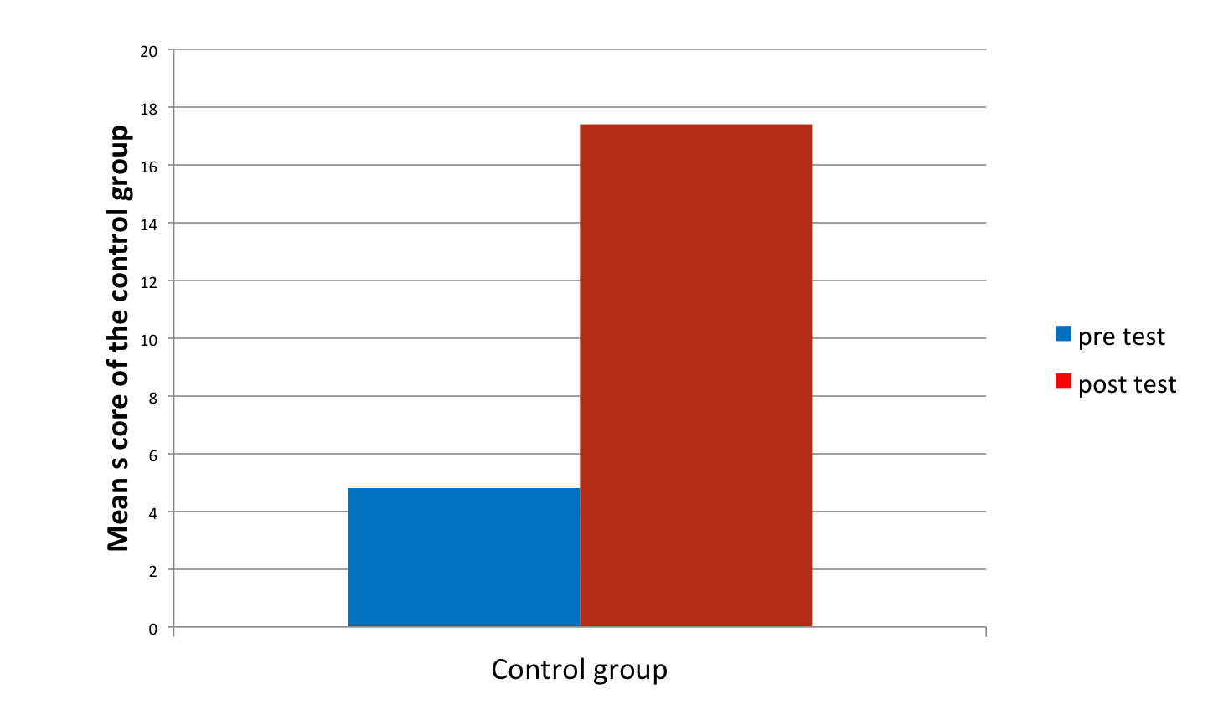
Table 4: THE t –RATIO OBTAINED BY CONTROL GROUP
Type of Test | Paired difference
 | Mean |  | Standard deviation | t | df | P-Value
Exptl Pre | 4.0 | 22  22 | -6.635 | 3.635 | 21 | -8.446
Exptl Post | 10.65
p value significant at 0.05 level

Table 5: Improvement scores of mathematical skills in post-test of experimental and control group.

Groups | Test | N | Mean | SD | Min | Max
Experimental | Post | 22 | 12.59 | 3.25 | 7 | 20
Control | Post | 22 | 6.55 | 3.64 | 2 | 15

Graph 3: POST- TEST MEAN SCORES OF EXPERIMENTAL AND CONTROL GROUPS
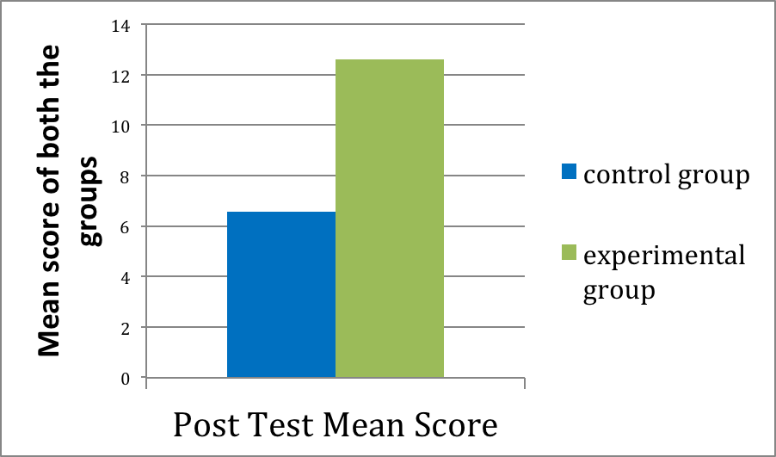
Table6: RESULTS OF INDEPENDENT t-TEST FOR MATH-SKILLS IMPROVEMENT SCORE

Paired Differences |  | t | df | P value
Mean | Sd
6.045 | 1.039 | 5.818 | 42 | .000

In the present study the students getting the Touch math intervention were able to solve math problems with greater ease and less effort as compared to those students who were taught through the traditional method.
In the present study, it was observed that the subjects from the experimental group who used fingers for counting prior to the intervention had stopped finger counting after the Touch math intervention. All the subjects were more confident in solving sums with carry over and borrowing and showed improvement in speed and accuracy compared to those in control group. Also during intervention, the experimental group was provided with direct instructions and corrective feedback at every step to encourage and motivate subjects for further learning of skills.
The experimental group showed lower variability at the post-test, which indicates that there is significant difference in the mean scores of the pre-test and post-test on math skills of the experimental group and all the subjects improved their performance.
Das (1968), Bhardwaj (1987) & Gable (1991) provide support to the above finding that remediation provide in the area of Mathematics leads to significant improvement in the performance of mathematical skills.
In the present study, the researcher observed that all the subjects of the experimental group who received Touch math intervention, improved their math skills. Despite the differences in the degree of achievement, all of them were able to carry out 3- digits addition and subtraction with and without carry over and borrowing respectively, with speed and accuracy. The students relied heavily on their fingers for calculation, and the answers were incorrect several times. Sums involving carry over were particularly tough, as they would often forget to count the carry over or forget to carry over at all. In case of subtraction the common errors found were starting the calculation from left side, subtracting larger number from the smaller number and got confused with the computation signs in case of mixed addition and subtraction sums.
Geary, (1999), believed that “if early identification and diagnosis were insightful and remediation implementation successful, the high at risk child would receive the kind of attention and help which results in successful school performance.”
After the intervention, in the present study, the errors decreased as skill in Touch Math strategies increased with regular practice. It was observed that confusion with the operation was also resolved as the subjects got used to verbalizing the problem before starting the calculations. The touch points made the subjects more confident in computation. Addition with carry over became easier as an extra box was provided. Subtraction with borrowing was clearer due to improved efficiency in counting backwards and the borrowing statement “Bigger bottom better borrow” helped. The researcher also got the feedback from the teachers that the student’s interest, attitude, confidence, speed and accuracy have increased and they would eagerly wait for more Touch Math sessions.
Grattino’s (2004) in a national survey on Touch Math, observed that students’ improvements attributed to the use of Touch Math included, better computational skills, consistently correct answers, more confidence in the area of mathematics and problem solving, increase in student’s self-esteem and ability to work independently. May (2008), shows co-relation of Touch Math and their computation scores on children with Learning Disabilities. The baseline mean showed a 42% with a median score of 36%. The intervention mean showed at 45.1% with a median score of 46.6%, showed an increase in computational scores and fluency. Finally, the maintenance condition showed a mean of 63.3% and a median of 61.4%, which demonstrates a 50% increase of scores. Overall, the mean score shows 48.4% and a median score of 51%. The standard deviation across all phases places at 14.5. This data suggested that Touch Math is a valid intervention for this population of students in a diverse classroom.
Dulgarian (2000) who conducted a study to find out if there was a difference in intervention on Touch Math V/S Traditional Intervention. The results indicated that Touch Math was a more effective method for teaching students with mild learning disabilities than traditional method. The study concluded that Touch Math students:
- were able to solve math problems faster and more accurately than their counterparts
- showed improvement of 24% on accuracy and 23% on time in comparison to the traditional group who showed improvement of only 13% on accuracy and 2% on time
- could count quickly and accurately without counting on fingers unlike the traditional group who still use fingers and made careless mistakes
- demonstrate a more confident demeanour
Hence the study and the data above supports the fact that the Touch Math Programme of teaching Math-Skills leads to better acquisition of maths skill over the Traditional Method of teaching Math -skills.

References:
- Bhardwaj, (1987). Standardisation of comprehension diagnostic test and preparation of remedial material in mathematics for middle standard students of Haryana, Ph. D Ed Kurukshetra University in forth survey of research and education, N Delhi, 1983-88

- Das, M., (1968). Effect of remedial teaching in arithmetic, a study with grade IV pupils, SIE, Assam in Fourth Survey of Research and education, Vol.1, National Council of Educational research and training, N Delhi 1983-88

- Dulgarian, D. (n.d.). Touch Math intervention versus traditional intervention: Is there a difference? West Los Angeles: University of California, Los Angeles.

- Fincham, L.& Meltzer L.(1976) .Arithmetic Achievement Of Learning Disabled On Key Math And Conservation Tasks. South African Journal Of Pychology,Vol.6,Pp80-86

- Gable, A (1991). A Practical Model for Curriculum Based Assessment and Instruction in Arithmetic. Teaching, Exceptional Children, 24, Pp 6-9

- Garnett, K. (1998). Math Learning Disabilities. LD Online, Retrieved 12/1/2011, from http://www.ldonline.org

- Geary, D. C. (2004). Mathematics and learning disabilities. Journal of Learning Disabilities, 37(1), 4–15.

- Geary, D. C. (2006) Learning Disabilities. Dyscalculia at an Early Age: Characteristics and Potential Influence on Socio-Emotional Development. Centre of Excellence for Early Childhood Development Encyclopedia on Early Childhood Development

- Gersten, R, Beckmann, S, Clarke, B, Foegen, A, & Marsh, L. (Panel, 2009). Assisting Students Struggling With Mathematics: Response To Intervention (RTI) For Elementary And Middle Schools

- Grattino, S. (2004). TouchMath national educator survey. Retrieved April 2, 2009, from www.touchmath.com/index.cfm?fuseaction=about.research

- Goldman, S.R., Pellegrino J.W, & Mertz D.L. (1988(Extended practice of basic addition facts: Strategy changes in Learning Disabled students, Cognition and Instruction, 5,223-265

- Jordan, N.C., Huttenlocher, J., & Levine, S.C. (1992). Differential Calculation Abilities in Young Children from Middle- and Low-Income Families. Developmental Psychology, 28, 644-653.

- Kirk, S. & Gallagher, J. (1989). Educating Exceptional Children, Sixth Edition. Boston: Houghton Mifflin Co.

- Lerner, J. (1993). Learning Disabilities. Boston: Houghton Mifflin Company

- Lock, R.H. (1996). Adapting Mathematics Instruction In The General Education Classroom For Students With Mathematics Disabilities. LD Forum, 21(2), 19-23.

- Mastropieri, M., & Scruggs, T. (2007). The inclusive classroom strategies for effective instruction. Columbus: Pearson Prentice Hall.

- Mays, D. (2008). Touchmath: an intervention that works. Unpublished masters research in education, Asbury College.

- Rea, R.E.&Reys R.E. (1970) Mathematical competences of entering kindergarteners, In K.D.Reid.Teaching the learning disabled-A Cognitive Developmental Approach.Allyn &Bacon: U.S.A., 1981

- Scott, K. S. (1993). Multisensory mathematics for children with mild disabilities. Exceptionality, 4(2), 97-111.

- Simon, R. & Harahan, J. (2004). An evaluation of the Touch Math method for teaching addition to students with learning disabilities in mathematics. European Journal of Special Needs Education, 19(2), 191-209.21.

- Strauss, A, A.; Lehtinen, L.E. (1947). Psychopathology and education of the brain-injured child, Oxford, England: Grune & Stratton. 206 pp.

- Vinson. B (2005) Touching Points on a Numeral as a Means of Early Calculation: Does this Method Inhibit Progression to Abstraction and Fact Recall? Retrieved on 23/6/11 from http://www.touchmath.com

- Wood, M.H. Modern Mat the Learning Disabled Child. Academic Therapy, 15, pp. 279-290, 1980

